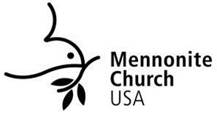

The goal of Mennonite Church USA church planting initiatives is to create and nurture missional peace churches — communities of people gathered together by Jesus whose life and witness reflects the gospel of peace and who are engaged in their local settings. The Thrive: Church Planting Grant is one way MC USA supports church plants across the United States.
There are two components of Thrive. The primary purpose is to provide direct grants to new church plants. A secondary purpose is to provide funds for coaching through Mennonite Mission Network.

Direct Grants
MC USA will provide a $5,000 annual grant per approved church plant, renewable up to three years (maximum number determined by available funds). These funds are provided directly to the church plant and can be used for any ministry purpose as determined by the leadership of the church plant (i.e. programing, staff, facilities, etc.).
To be considered for this grant, please read the Thrive: Church Planting Grant FAQ, fill out the grant application, and email it to MichaelD@MennoniteUSA.org. Grant decisions will be made in consultation with Mennonite Mission Network Sent Team.

Coaching
MC USA will also provide $5,000 per year to provide stipends to church planting coaches that are selected by Mennonite Mission Network – the primary driver of church planting in MC USA including equipping, coaching and support for peace churches in MC USA.
If you are qualified and interested in being a church planting coach please contact Mauricio Chenlo – MauricioC@MennoniteMission.net

We pray that these initiatives will provide much needed support for church plants and planters, while also allowing church plants autonomy and freedom as they follow the Spirit in their mission.

