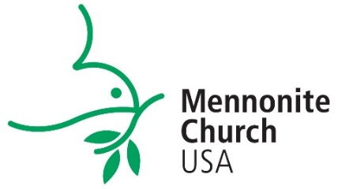

Ministerial Leadership Information Form (MLI)
A Checklist for Pastors

¾ STAGE ONE – INQUIRY
WHAT YOU NEED TO DO:
- Complete the inquiry form found at http://mennoniteusa.org/resource/ministerial-inquiry-form/.
RESPONSE from MC USA (see contact info at the bottom of the page)
- Rachel Ringenberg Miller, Denominational Minister of Ministerial Leadership, will call you to discuss further steps. Assuming you are ready to proceed, Rachel will send you the MLI form link and instructions.
¾ STAGE TWO – MLI SUBMISSION
WHAT YOU NEED TO DO:
- Complete your MLI. Take your time to consider your answers. A thoughtful MLI submission often takes a few weeks. If you have questions or technical problems, contact Rod Hollinger-Janzen, Administrative Assistant for the Church Vitality Dept. (RodHJ@mennoniteusa.org )
- When you submit your MLI form, Rachel and Rod will receive a notification and the completed form.
RESPONSE from MC USA – WE WILL:
- Review and save your MLI to the office files.
- Collect the four references
- Send you an invoice via PayPal for the processing fee.
- Send you an MLI Submission letter and any additional background check information.
¾ STAGE THREE – THE DETAILS
WHAT YOU NEED TO DO:
- Complete and submit the Background Authorization form
- Make payment via PayPal
- Contact your references to confirm they received the form. Encourage them to reply promptly.
RESPONSE from the MC USA Office – WE WILL:
- Send your information to a company that runs background checks for us. It takes a few days until we receive the final report. (Some states, such as Virginia, take up to three weeks.)
- Collect and summarize your references.
¾ FINAL STAGE
After you submit your MLI, it usually takes about 2-3 weeks to complete your file with background report and all your references. When our office has received your
- MLI form
- “clear” background report
- payment
- four references
WE WILL:
- Send your MLI and Reference Summary to the conference offices that you have named or that have requested your file.
- At your request, add your name and information to the National Register which is shared with MC USA conference ministers (and MC Canada regional church offices, if requested).
- Send you an email reporting the completion and distribution of your MLI file.

I am in the office Monday through Friday, 9am-4pm Eastern (except when traveling)
Phone: 574-523-3010 (direct) or 1-866-866-2872 ext. 23010 (toll free)
Rachel Ringenberg Miller: RachelRM@mennoniteusa.org

