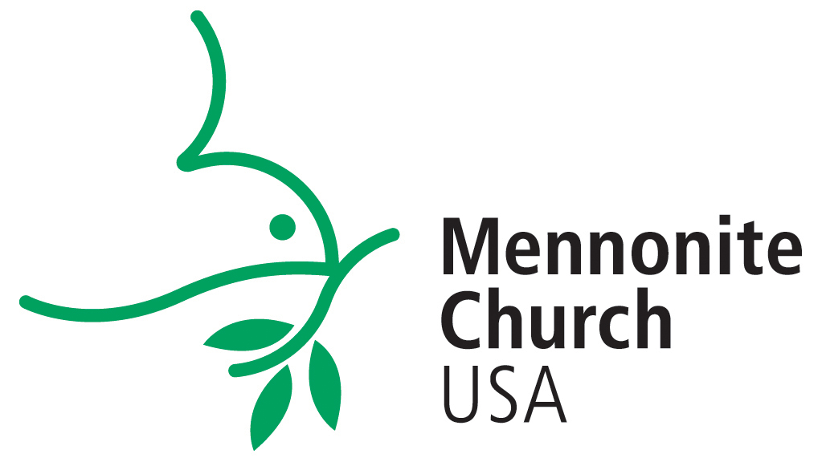

**Instructions for Candidate: Ministry Transitions Packet**

You have decided it is time to consider a new position for ministry and want to complete your Ministerial Information Form file (MLI). The denominational office and your area conference minister both want to work with you!

1. **Conference Office:** Check in with your area conference minister to talk about your call to ministry or your interest in a new ministry role.
2. **Ministry Inquiry Form**: Complete and submit the MLI Inquiry Form: <http://mennoniteusa.org/resource/ministerial-inquiry-form/>. We ask all candidates to submit this form—whether you are new to ministry or a long-time pastor.
3. **Inquiry Interview**: After you submit the Inquiry Form, the denominational office will contact you to set up a phone interview to discuss your plans and explain the MLI process and the electronic form.
   * NOTE: If you are not a member of Mennonite Church USA, you will be asked to complete a Placement Protocol document prior to your inquiry interview.
4. **Background Reading Materials:** To complete the MLI, you will need to obtain two booklets for reference:

* [Confession of Faith in a Mennonite Perspective](http://store.mennomedia.org/Confession-of-Faith-in-a-Mennonite-Perspective-P408.aspx)
* [A_Shared_Understanding_of_Ministerial Leadership](http://store.mennomedia.org/cw_Search.aspx?k=A+shared+understanding+of+Church+leadership) describes our polity for ministerial leadership which includes credentialing understandings and procedures.

**Notes for completing the Ministerial Leadership Information form (MLI)**

* Prepare an accurate and balanced portrait of yourself in the MLI. Since the MLI is an introduction of you, there is a character limit on certain sections of the MLI to encourage short, precise answers. You can always expand on your answers in an interview process.
* **Salary:** You are free to indicate the amount of salary you think you need. An alternate approach is to state that you will accept the denominational guidelines (The guidelines are developed by the denominational office and posted on the website).
* **References:** You will need to identify three personal references and their email addresses, ideally persons who know you best and with whom you have had contact in the past few years. Your required fourth reference will be your area conference minister or, if you are in school, the name of the director of field education (the person who has an awareness of your whole academic experience).
* If you are currently **serving in ministerial leadership**, include your area conference minister, a ministerial colleague, a lay leader within your congregation, and one other person.
* **Background check:** We run a background check for all candidates.
* **Processing fee:** Our office charges a processing fee, which includes the cost of the background check. We will bill you upon submission of the MLI. This payment is nonrefundable and does not guarantee a ministry position.
* **Completion of MLI file:** Your candidating file is ready for circulation to area conference ministers who work with congregational search committees, when

1. your MLI form is completed
2. four references are received and the composite is completed
3. background check run with a “clear” record reported
4. you have paid the processing fee

Our office will contact you by email to inform you that your file is complete and ready for circulation. Completion of your file does not guarantee any ministry position.

* **Right to discontinue the MLI process:** The denominational office reserves the right to discontinue the MLI for a candidate, if

1. one or more references raises serious negative issues
2. a reference refuses to submit a reference
3. an area conference minister or field education supervisor cannot provide a positive recommendation for ministry
4. the candidate shows theological incompatibility with the *Confession of Faith in a Mennonite Perspective*.

**My MLI file is complete—What’s next?**

* **Sharing your MLI file:** In your MLI, you will indicate the conferences with which you want to share your file. The MC USA office will send them a copy of your MLI form, a reference summary, and confirmation of your clear background report.
* **The National Register:** A list of pastoral candidates with brief biographical information is shared with area conference ministers, who may then request to see your MLI file and may contact you for further discussion. This Register only includes names of persons who request to be on the list and are open to considering a wide geographical range.

A candidate's name will be maintained on the list for up to two years. At that point we recommend a discussion to discern next steps. If you wish to be re-listed after being off of the list for a period of time, your MLI form will need to be revised if it is more than two years old.

* **Contacts:** An area conference minister is your best ally in searching for a placement. Hard, honest questions can be asked of an area conference ministers without compromising your first impression on the search committee. If contacted first by a congregational leader, we strongly recommend that you ask whether the congregation is working with their area conference minister.
* **What if no one is calling:** Sometimes your best efforts will not result in making the sought for pastor‑congregation connection as quickly as hoped. Maintain close communication with an area conference minister who is working with congregations and search committees for appropriate counsel.
* **Leave-taking your current ministry role:** There is no exact point of time when resignation from your present position is required or appropriate. During the candidating process, it is wise to consult with your area conference minister to determine the best time to announce your resignation from the congregation you currently serve. We generally advise that candidates retain their current position during the "exploration" phase of the candidating process. However, once you are “negotiating” with one congregation or are introduced publicly to the congregation, it is also time to be announcing your resignation from your present congregation. The Alban Institute has a number of very helpful publications on healthy transitions and goodbyes. See [www.Alban.org](http://www.alban.org/https:/alban.org/?s=ministry+transitions).
* **Other resources:** Check the other documents in the [Ministry Transitions – Candidate Packet](http://mennoniteusa.org/resource/ministry-transitions-candidate-packet/) on the MC USA website, including a sample Covenant of Understanding, Salary and Benefits Guidelines, and a sample interview guide.

***Disclaimer:*** *The registration of a person with the denominational office and the appearance of a person’s name on the National Register do not constitute an official endorsement of the individual. Neither does it promise the person any ministry position. The basis for evaluation of any particular person or congregation includes the information given on their respective forms, the information given by references, and the interviewing process between a candidate and a congregation.*

*April 2020*