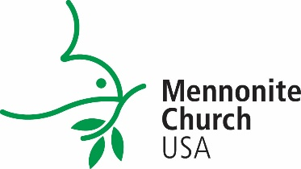

MINISTRY INQUIRY PROGRAM
Memorandum of Agreement

A Ministry of Mennonite Church USA, The Ministry Inquiry Program provides opportunity for students at Mennonite Church USA colleges to explore pastoral ministry*.

*”Pastoral” to mean primarily in congregational settings with allowance/flexibility of exploring alternative 'pastoral experiences' (e.g. camp, service agencies) as a part of their summer congregational placement experience.

The Ministry Inquiry Program is an opportunity for college-level persons to observe and participate in the life and ministry of a pastor and a congregation.

1. The undersigned do hereby agree that:

___________________________________, student at _______________________________
Name of student Name of college

and _______________________________, pastor of _______________________________
Name Congregation

at ________________________________________, commit themselves to
City State/Prov.

participate in the Ministry Inquiry Program from _________________to___________________
Date Date (11 weeks is normal expectation).

2. The student shall work the equivalent of one full-time position with the hours of responsibility to be determined by the student and pastor.

3. The student shall be responsible to the pastor for work/observation and on-site supervision.

4. The student shall be remunerated $500 (total) personal allowance by the host congregation on either a weekly or monthly basis.

5. The student(s) shall be provided housing by the receiving congregation.

6. The student and pastor shall consider observation and tasks that exemplify the full range of pastoral responsibility as written in the MIP Supervision Guidelines.

7. The student and pastor shall participate in periodic informal evaluations throughout the duration of the program. Each party shall provide written evaluations at the conclusion of the inquiry experience to the responsible college administrator, conference ministers (both home and receiving), and Mennonite Church USA administrator.

8. Following the submission of final reports, the designated college administrator shall collect funds from each group, i.e. home congregation, receiving congregation, area conference, denomination and college.

9. ______________________________ shall provide a Ministry Inquiry scholarship in the
(Name of college)
amount of $2,000 for the participating student’s next year’s financial aid award.

10. We intend to fulfill these expectations to the best of our abilities.

__________________________________________ _______________
Pastor Date

__________________________________________ _______________
College coordinator Date

__________________________________________ _______________
Student Date

CHECK-LIST FOR COLLEGE ADMINISTRATOR

Funds have been promised by and will be gathered by student’s college administrator:

_____ Home congregation: ($500)____________________________

_____ Receiving congregation: ($500)__________________________

_____ Area conference(s): ($500)________________________ __________________________

_____ College: ($500) ________________________________

_____ Mennonite Church USA ($500)

_____ Sent copy of student reflection paper to all participating parties.

