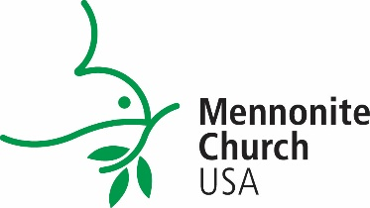

Date: (add)
To: (add name of Ministry Inquiry Program supervisor)
From: (add name of campus administrator)
Re: One-Month Review

On behalf of Mennonite Church USA, we appreciate your work with your student this summer as part of the Ministry Inquiry Program! Currently, you are about midway through the summer internship experience. At this midway point, we would value a brief review of how things are progressing with your student. Please respond briefly to the questions below and return your responses via e-mail to (add college admin email here). As you answer these questions, please keep the student’s Inquiry Goal sheet in mind.

Thank you!

1. What has gone especially well as your student has begun the assignment?

2. How has the student adjusted to this placement? Have you encountered any problems
in working with your student that we should be aware of at this point?

3. Can you briefly respond to how the student’s orientation/welcome, role description, and
weekly check-in meetings are going?

Your name & title:
Student name:
City, State, & Zip:
Phone#:
Email:

