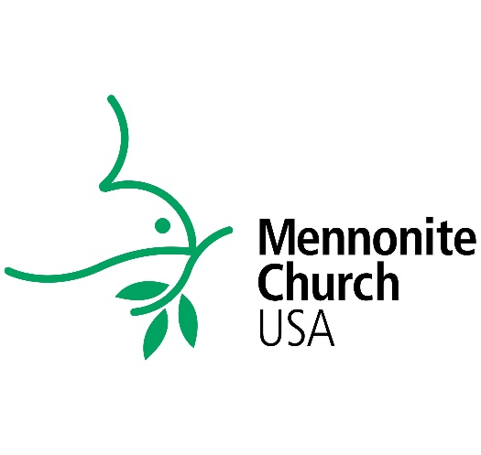
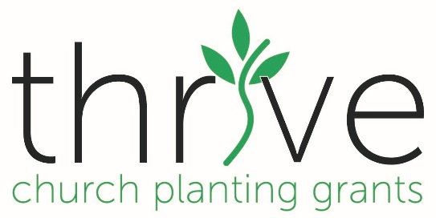

Grant Season: Each grant seasons runs from August 1 – July 31. The full amount of the grant is disbursed in August, to be used through the August 1 – July 31 grant season.
Grant Season: August 1 – July 31

Application Period: May 1 – July 31

Application Period: Each year, MC USA processes grant application in May, June and July for the upcoming grant season. Award letters are sent and grants disbursed in August. New applications are welcome throughout the year, however, they will not be reviewed until the next application period (i.e. one can submit a grant application at any time – Sept. through July - but it will not be processed until May, June, and July for the next grant season). Any grant applications received in August will be deferred to the following grant season. Current grant recipients can submit a renewal application in May.

